ASPECT Operations Plan for the

Deployment to the 2015 Albuquerque International Balloon Fiesta

2 – 11 October 2015



City of Albuquerque, New Mexico
New Mexico State Police
U.S. EPA Region 6
U.S. EPA ASPECT Team

ASPECT Operations Plan for the

Deployment to the 2015 Balloon Fiesta

2 –11 October 2015

Situation. The US Environmental Protection Agency Airborne Spectral Photometric Environmental Collection Technology (ASPECT) will be deployed to support US EPA Region 6 for the 2015 Balloon Fiesta located in Albuquerque, New Mexico. The deployment will be from 2 October through 11 October 2015. This Operations Plan details the components of the ASPECT Program and defines the roles and responsibilities of the participants involved in the deployment.

ASPECT System Description. The ASPECT components are installed and operated from an airplane capable of providing 24/7 chemical and radiological detection and can be forward deployed or respond to any location in the U.S. The system uses two chemical sensors and a radiological sensor to detect and map chemical plumes and radiological sources and deposition. The ASPECT chemical sensors include a high resolution (0.5 meter pixels) multi-spectral infrared line scanner that produces a two dimensional image and a point detection Fourier Transform Infrared Spectrometer (FTIR) that can be used to obtain detailed chemical information of any point in the plume. Radiological detections are made using a multi-detector sodium iodide sensor using full geospatial registration. Visible imagery is collected using a high resolution digital camera system. All data is geo-referenced with embedded geographical coordinates and can used in a variety of GIS systems.

Bi

Figure 1 -- ASPECT

ASPECT provides a preliminary indication of the chemical composition of a release and elevated radiation levels within 5 minutes with independent confirmation in 15 minutes. The results are communicated directly to the OSC for further analysis. Additional information on the ASPECT system and the aircraft are listed in Appendix B.

General Concept. The deployment time-line is provided in Appendix A. Deployment to support the Balloon Fiesta will start on 2 October and will operate from the State of New Mexico Department of Homeland Security Headquarters and the command station on the grounds of the Balloon Fiesta. All data processing will be performed at the grounds command station and if necessary at the State Homeland Security HQ. For the Balloon Fiesta deployment, the ASPECT aircraft will be located at the following FBO:

Landmark Aviation
121 Aviation Dr. Bldg 3005
Santa Fe, NM 87507
505-471-2525

The ASPECT deployment is in support of Region 6 and all data will be routed according to Region 6 procedures. The following data products will be generated by the aircraft including chemical IR spectra, IR imagery, visible imagery and radiological spectra. Chemical and radiological data will be processed while the aircraft is on station using both onboard automated software and ground-based software tools. A satellite system will be used to transmit chemical and radiological data to the ground team while the aircraft is in flight status. All data will be examined for Quality Assurance prior to release. The OSC will have complete access to all data (tentative and final) and will be the data custodian for all released information. Per the direction of the OSC, once data has been QA checked, all products can be released directly to the State of New Mexico.
Communications and Contact Information. Logistical communication procedures, conference bridge information and ground to air frequencies are detailed in Appendix D. Appendix E contains detailed information for contacting key individuals during the deployment. Digital sensor data will be available at the FTP site per Appendix C.

Appendixes:
A - Proposed ASPECT Flight Plans and Profiles
B - Detailed ASPECT Technical Data
C – ASPECT Data Routing, Storage, and Viewing
D - Communications
E – Contact Information

Appendix A
Proposed ASPECT Flight Plans and Profiles

Two flight configurations are planned to provide data to support the Balloon Fiesta event. On selected mornings of the deployment window, ASPECT is scheduled to fly a radiological survey over the balloon field. It is expected that this flight will be initiated at about 0500 and will last about 30 minutes. The radiological survey will be conducted at an altitude of 300 feet above ground (AGL) (Figure 1) with a line spacing of 600 feet. A second flight will be conducted at 1300 and which will collect chemical and imagery data over the balloon field (Figure 2). Chemical and imagery data will be collected at an altitude of 3000 feet AGL (above the TFR) with a line spacing of 1500 feet. Flight profile information is provided in Table 1. All data will be processed and uploaded to a secure FTP site. A username and password will be available for the FTP site upon request.

Upon completion of the radiological survey, ASPECT will process all data and generate a sigma plot. This plot will be transmitted to the ASPECT technical POC stationed with the State Manager. If detection is made, additional analysis will be conducted once the aircraft returns to Santa Fe. A similar process will be used for chemical data collection.

Table 1 – Data Collection Profile
Dates | Time Block | Mission | Comments
2 Oct 2015 |  | Aircraft and reach back mobilization  Baseline data collection
3 Oct 2015  and  4 Oct 2015 | 0500-0600  0605  0730  1300-1400  1405-1430  1530 | Radiological data collection (300 AGL)  Radiological sigma plot delivery  Radiological exposure plot deliver  Chemical/photo data collection (2800 AGL)  Chemical products delivery  IR and photo imagery delivery
5 Oct 2015 and  6 Oct 2015 |  | Active Standby | No flights scheduled, work on systems
7 Oct 2015 | 0500-0600  0605  0730 | Radiological data collection  Radiological sigma plot delivery  Radiological exposure plot deliver
8 Oct 2015 and  9 Oct 2015 |  | Active Standby | No flights scheduled, work on systems
10 Oct 2015  and  11 Oct 2015 | 0500-0600  0605  0730  1300-1400  1405-1430  1530 | Radiological data collection (300 AGL)  Radiological sigma plot delivery  Radiological exposure plot deliver  Chemical/photo data collection (2800 AGL)  Chemical products delivery  IR and photo imagery delivery
* Times are Mountain Standard Time

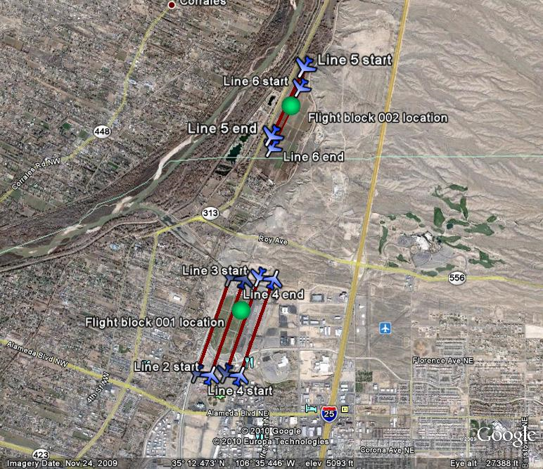
FIGURE 1 - Flight Lines for Radiological Collection

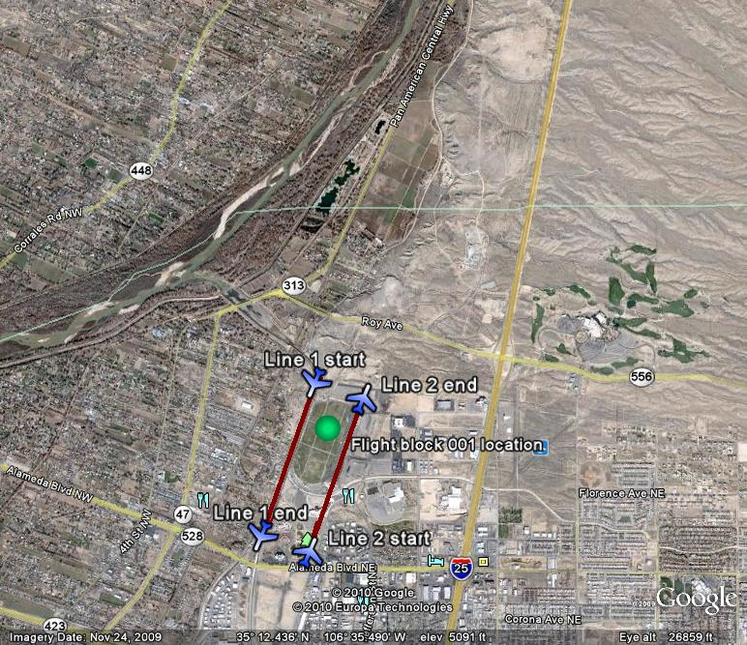
FIGURE 2 - Flight Lines for Chemical and Aerial Imagery Collection
Appendix B
ASPECT Technical Description

The ASPECT sensor suite (Figure 1) is mounted in a fixed wing aircraft and uses the principles of remote hazard detection to image, map, identify, and quantify chemical vapors and deposited radioisotopes. Chemical plume measurements are made at a rate of about two square miles per minute. The system normally operates at an altitude of 2800 feet above ground level (AGL) and results in a high IR spatial resolution of 0.3 meters. A simplified system diagram is provided in Figure 2. The radiological data is collected between 300 and 500 feet AGL with a collection time of once per second and a field of view about 600-1000 feet.

Supporting data includes high-resolution aerial digital photography and digital video that are concurrently collected with chemical and radiological data and forms the basis for a geographical information system data cube with several layered data products (Figure 3). Efficient mission execution requires that data is processed on-board the aircraft for transmission or hand-off to the first responder. To facilitate data transmission while in flight status, the aircraft is equipped with a broadband high-speed satellite data communications system. With a combination of onboard data processing and the satellite communication system, selected airborne situational data sets are ready for dissemination to the incident command team in less than 5 minutes after collection.

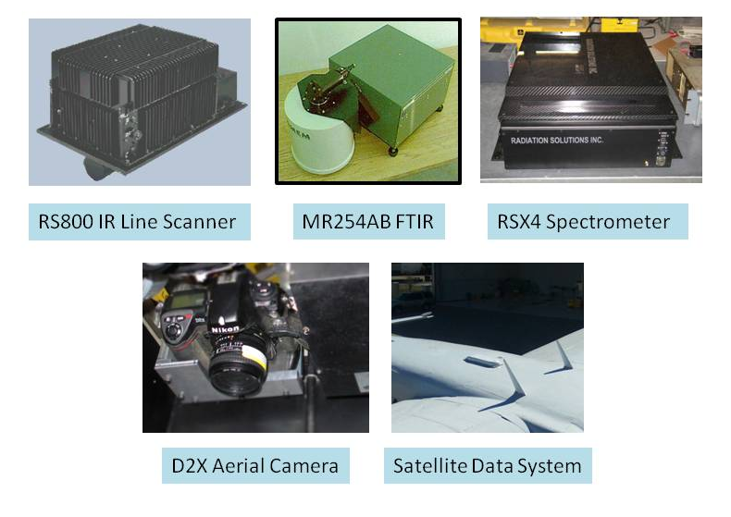
FIGURE 1 – Sensor Suite

NOTE: Images of the neutron detector and LaBr detectors are not shown. The aircraft is equipped with three RSX-4 units, only one is shown in this figure.
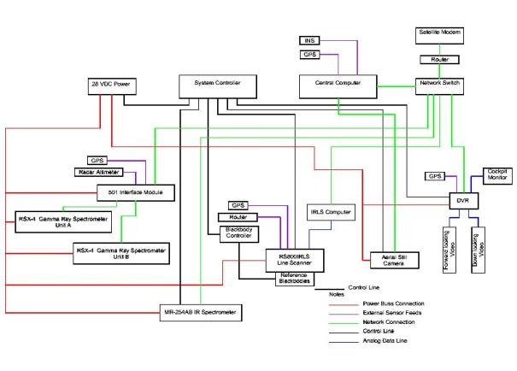
FIGURE 2 - Simplified ASPECT System Diagram

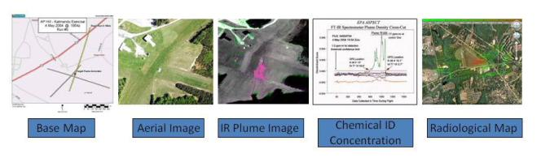
FIGURE 3 – Data Products

    - Airframe

The ASPECT sensor suite is operated from a single engine Cessna 208B Cargo Master aircraft (Figure 4). The aircraft and crew are certified for full instrument flight rules (IFR) flight operations. This aircraft is equipped with one 20 X 30 inch belly hole with a retractable bay door. All sensor systems are mounted on vibration isolated base plates positioned over the belly hole. The aircraft can operate from any airport having a 3000 ft runway and can stay aloft for 5 hours. Technical specifications for the program airframe are contained in Table 1.



FIGURE 4 – ASPECT Aircraft, N9738B

TABLE 1 – N9738B Technical Specifications
Tail: | N7938B
System: | Single Engine Turbo-Propeller Driven Aircraft
Make: | Cessna 208B Cargo Master, Part 91 Certification
Power Plants: | Pratt and Whitney PT-6A-114 turbine driven three blade propeller, 600 shaft HP
Empty Weight: | 4458 lbs.
Useful Weight: | 4604 lbs.
Maximum Take-off Weight: | 9062 lbs.
Typical Cruise Speed: | 160 Kts
Typical Flight Duration: | 6 Hours (65% Power) Plus 45 Minute Reserve
Service and Ceiling: | Low Altitude Waiver, 25000 Ft (MSL) max altitude
Cabin: | Un-pressurized, Crew Oxygen
Portals: | One, 20 X 30 inch STC sensor hole with Remote Door
Avionics | GPS IFR Package  GPS navigation system for programmed flight lines  Terrain/Obstacle Avoidance Equipped  Radar Altimeter Equipped  Dual weather Radar, Live Weather Feed  Dual VOR Equipped,Dual Comms Equipped  Dual Transponders
Electrical Buss: | Primary, 28 vdc @ 200 amps full load  Secondary, 28 vdc @ 90 amps full load
Data Communication: | Phased Array Satellite System, 40-60 KB/sec Data/Telephone combined
Readiness Status: | 24/7/365

    - Chemical Detection Capabilities

The principle of remote detection, identification, and quantification of a chemical vapor species is accomplished using passive infrared spectroscopy. Most vapor compounds have unique absorption spectral bands at specific frequencies in the infrared spectral region. An asymmetric stretching between two atoms in a molecule results in a fundamental frequency of vibration. Passive infrared measurements of a vapor species are possible due to small thermal radiance differences between the temperature of the chemical plume and a particular infrared scene background (Figure 5). Both the cloud and the atmosphere contribute to the total emitted radiance measured by an infrared sensor. Careful monitoring of the change in total infrared radiance levels leads to concentration estimations for a particular vapor species. Concentration times path length estimations are obtained based on the molar absorptivity for each vapor species.

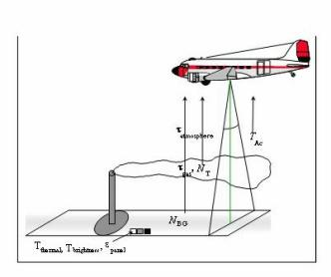
FIGURE 5 - Principles of Remote Infrared Detection

      - Equipment - RS800IRLS Infrared Imager
The ASPECT Program uses a modified Raytheon RS800 infrared line scanner to generate wide area chemical imagery (Figure 6). This system incorporates a unique detector assembly consisting of 16 cryogenically cooled optical band pass filters affixed to a focal plan array. Scanning is accomplished with an integrated rotating prism controlled by a feedback motor scan controller. Each rotation of the prism sweeps an angular field of view of 60 degrees resulting in 1500 data points. When the scan rate is coupled to the normal 110-knot ground speed of the aircraft, a scan swath of 0.5 meters is collected. This collection geometry outputs a square data pixel 0.5 X 0.5 meters square. Radiometric calibration is performed during each prism rotation by viewing two reference blackbodies mounted on either side of the unit. Image registration is accomplished during post processing by incorporating pitch and roll data collected from an integrated gyroscope mounted on the scanner body. An integrated GPS receiver is used in the processing step providing geo-registration of each pixel in the finished image product. Detailed specifications of the RS800IRLS are contained in Table 2.

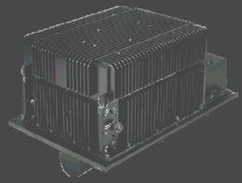
FIGURE 6 - RS800IRLS Line Scanner

TABLE 2 - RS800IRLS Technical Specifications
System: | TI Systems/Raytheon RS800 MSIRLS
Detector: | Cryogenically cooled focal plane array with integrated cold optical filters
Spectral Coverage: | 3 – 5 micrometer (mid-wave) and 8 – 12 micrometer (long-wave)
Number of Spectral Channels: | 16 total, 8 mid-wave and 8 long-wave
Spectral Resolution: | 5 to 20 wave numbers, channel dependent
Spatial Resolution: | Better than 1.0 mill radian
Scan Rate: | 60 Hz
Radiometric Calibration: | Two flanking blackbody units
Field of View (FOV): | 60 Degrees
Thermal Resolution | 0.05 Degree C.
Linear Range | 0 to 200 Degree C
Pixel Resolution (IFOV): | 0.5 meters @ 850 meter collection altitude (AGL)
Cross Field Scan Coverage: | 980 meters @ 850 meter collection altitude (AGL)
Attitude Stabilization: | 25 Hz pitch and roll providing stabilized video
Power: | 28 vdc @ 10 amps full load
Weight: | 27 Kg (60 lbs.)
Spin-up Time: | Less than 12 minutes (including cyro-system)
Standard Outputs: | 2 Channels of stabilized RS-170 video, 16 channels of digitized (16 bit) spectral data, 1 channel of GPS (2 Hz)
Data Processing | 1 step full radiometric image generation using an onboard algorithm. Approximately 1 minute processing time.

        - IRLS - Chemical Image Processing

Processing of chemical data is divided into two broad categories including image processing and spectral processing. Infrared chemical signatures present a challenge in data processing due to the small signal to noise ratio (SNR) of the chemical vapor between the sensor and the surface. It is not uncommon to have a SNR of less than four in a typical vapor cloud. In order to image such a weak signal, the collection system and detector must be optimized for high collection efficiency and a small instantaneous field of view. The ASPECT RS800IRLS meets both of these requirements by using an F 1 high-speed optical train coupled to a 16-channel cold optical filter focal plane array. This configuration provides very high signal throughput while maintaining a 1.0 mill radian spatial resolution. The use of cold optical band pass filters directly mounted on the face of the focal plane array eliminates a large portion of the self-radiance (noise) while minimizing the attenuation of wanted signal content. Raw data is fully radiometrically calibrated using a set of flanking blackbodies providing radiance-adjusted imagery. Jitter removal and band registration are accomplished using an automated algorithm using an integrated 2 dimensional gyro and GPS feed. Final data is generated using an automated geo-registration algorithm in either a geo-Tiff or a geo-Jpeg format. Processing can be accomplished while in flight and requires about 30 seconds to 1 minute per image depending on size. The completed imagery is compressed and made available to ground user through the aircraft satellite link.

The vapor cloud, shown in Figure 7, is an infrared image collected by the RS800SIRLS multispectral sensor at an industrial site in the Midwest. The detection limit of the vapor concentration (shown in red) was determined to be less than 20 ppm/m while the center cloud concentration was greater than 250 ppm-m. This image has been cropped with only 1/3 of the actual sensor field-of-view being displayed. The original image width of the image was approximately 1200 meters wide. For the ASPECT application, the RS800IRLS system provides a qualitative indication of the presence or absence of a particular chemical species. The detection limit provided by the sensors is applicable to both chemical emergency response and crisis mitigation following a terrorism event.

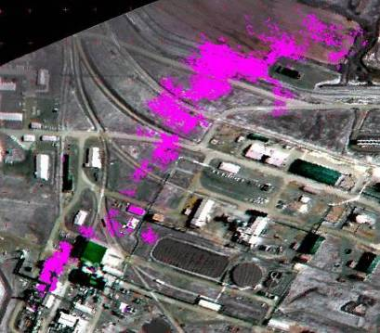
Figure 7 - RS800IRLS Data Product

Wind
Release Point

FT-IR Spectral Data
Thermal Image Processing

  - Equipment - MR254AB Spectrometer

Chemical vapor detection and quantification is accomplished using a modified Bomen MR254AB spectrometer (Figure 8). This custom designed spectrometer utilizes a double wishbone pendulum interferometer providing both high signal throughput and vibrational noise immunity. Two cryogenically cooled detectors provide both mid and long wave operation. Spectral resolution is selectable and ranges from 1 to 128 wave number with 16-wave number normally used for automated compound detection. When operated at 16 wave number resolution, the unit scans at 70 Hz providing a spatial sampling interval every 0.75 meters along the ground track of the aircraft. The program uses an automated compound detection algorithm based on digital filtering and pattern recognition. Geo-registration of each Fourier Transform Spectrometer (FTS) scan is accomplished using a concurrent GPS input from the ASPECT main GPS receiver. Technical specifications of the FTS system are contained in Table 3.

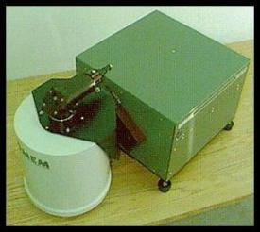
FIGURE 8 - MR254AB FTS Spectrometer

TABLE 3 - FTS Technical Specifications
System: | Modified Bomem MR-200 Series (MR-254AB)
Detectors: | Cryogenically cooled Single Pixel Design
Spectral Coverage: | InSb Detector for 3 – 5 micrometer (mid-wave) MCT Detector for 8 – 12 micrometer (long-wave)
Noise Figure | Mid-wave 6x10⁻⁹ W/cm²-srcm⁻¹, Long-wave 1.8x10⁻⁸ W/cm²-srcm⁻¹
Spectral Resolution: | 1 to 128 wave numbers, User selectable
Spatial Resolution: | 5 milli-radian (0.2º) thru 25.4 cm (10 inch) Primary Telescope, 0.75 meter interval at 110 kts collection velocity
Scan Rate: | 70 Hz @ 16 wave number resolution
Field of View (FOV): | 3 meters @ 850 meter collection altitude (AGL)
Radiometric Reference | Integrated cold source (77º K)
Targeting | Calibrated bore camera (Nadir)
Power: | 28 vdc @ 8 amps full load
Weight: | 40 Kg (90 lbs.)
Spin-up Time: | Less than 4 minutes (including cyro-system)
Standard Outputs: | 2 Channels of Grams format spectral data (16 bit), 1 channel of RS-170 video.
Data Processing: | 1 Step pattern recognition compound detection using onboard algorithms, approx. 30 – 60 seconds processing time after data collection.

        - Spectral Processing

Spectral data processing (signal processing) from the ASPECT MR-254AB spectrometer is processed using background suppression, pattern recognition algorithm. Processing spectral data from a moving airborne platform requires unique methods to balance weak signal detection sensitivity, false alarm minimization, and processing speed. The background suppression, pattern recognition methods associated with the ASPECT Program have been documented in over 100 open literature publications.

One of the principal weaknesses of airborne FTS data is the ability to reference each collected spectra to a suitable background for subsequent spectra subtraction. While methods have been devised to accomplish this procedure, typical airborne spectra show changes between successive scan of several orders of magnitude due to changing radiometric scene conditions. These scan-to-scan changes render traditional background subtraction methods unusable for weak signal detection. The background suppression method used by ASPECT circumvents this problem by using a digital filtering process to remove the background component from the raw interferometer data. This approach is analogous to using the tuning section of a radio receiver to preselect the portion of the signal for subsequent processing. The resulting filtered intermediate data maintains the weak signal components necessary for subsequent analysis.

An additional weakness of traditional FTS processing involves the need to provide a resolution high enough to permit compounds exhibiting narrow spectra features to be matched with published library spectra. This method is initiated using the Fast Fourier Transform (FFT). While the FFT algorithm is very robust mathematically, certain data collection requirements must be met to permit the transform to be valid. In order to provide high spectral resolution spectra, the length of the interferogram must be matched to the desired resolution for the transform to work properly. This requirement forces a long collection period for each interferogram and since the aircraft is moving, it is probable that the radiometric scene being viewed by the spectrometer will change during the collection of the interferogram. The changing scene causes the FFT to generate spectral artifacts in the resulting spectral information. These artifacts are phantom signals that confuse and complicate subsequent compound identification.

The standard matched filter compound discrimination method likewise exhibits weak signal performance and often generates false alarms due to common atmospheric interference. ASPECT solves these problems by using a combination of digital band pass filtering followed by a multi-dimensional pattern recognition algorithm. The digital filters and pattern recognition coefficients are developed using a combination of laboratory, field, and library data and folded into a training set that is run against unknown data. Digital filters can be readily constructed which take into account both spectrometer line shapes and adjacent interferents, greatly improving the weak signal system gain. The pattern recognition algorithm processes the filter output in a multi-space fashion and enhances the selectivity of the detection. These methods are very similar to a superheterodyne receiver that uses band pass adjustable intermediate filters followed by a DSP detector/discriminator such as in a modern radar system. Since the methods use relatively simple computational operations, signal processing can be accomplished in a few seconds. Finally, as data is processed, the position of the detection is referenced to onboard GPS data providing a GIS ready data output. Table 4 lists the compounds (and a 10 meter equivalent path length detection limit) that are currently installed in the airborne library using the digital filtering/pattern recognition method.

TABLE 4 - Chemicals Included in the ASPECT Auto-Processing Library
Acetic Acid (2.0) | Cumene (23.1) | Isoprene (6.5) | Propylene (3.7)
Acetone (5.6) | Diborane (5.0) | Isopropanol (8.5) | Propylene Oxide (6.8)
Acrolein (8.8) | 1,1-Dichloroethene (3.7) | Isopropyl Acetate (0.7) | Silicon Tetrafluoride (0.2)
Acrylonitrile (12.5) | Dichloromethane (6.0) | MAPP (3.7) | Sulfur Dioxide (15)
Acrylic Acid (3.3) | Dichlorodifluoromethane (0.7) | Methyl Acetate (1.0) | Sulfur Hexafluoride (0.07)
Allyl Alcohol (5.3) | 1,1-Difluoroethane (0.8) | Methyl Ethyl Ketone (7.5) | Sulfur Mustard (6.0)
Ammonia (2.0) | Difluoromethane (0.8) | Methanol (5.4) | Nitrogen Mustard (2.5)
Arsine (18.7) | Ethanol (6.3) | Methylbromide (60) | Phosgene (0.5)
Bis-Chloroethyl Ether (1.7) | Ethyl Acetate (0.8) | Methylene Chloride (1.1) | Phosphine (8.3)
Boron Tribromide (0.2) | Ethyl Formate (1.0) | Methyl Methacrylate (3.0) | Tetrachloroethylene (10)
Boron Triflouride (5.6) | Ethylene (5.0) | MTEB (3.8) | 1,1,1-Trichloroethane (1.9)
1,3-Butadiene (5.0) | Formic Acid (5.0) | Naphthalene (3.8) | Trichloroethylene (2.7)
1-Butene (12.0) | Freon 134a (0.8) | n-Butyl Acetate (3.8) | Trichloromethane (0.7)
2-Butene (18.8) | GA (Tabun) (0.7) | n-Butyl Alcohol (7.9) | Triethylamine (6.2)
Carbon Tetrachloride (0.2) | GB (Sarin) (0.5) | Nitric Acid (5.0) | Triethylphosphate (0.3)
Carbonyl Chloride (0.8) | Germane (1.5) | Nitrogen Trifluoride (0.7) | Trimethylamine (9.3)
Carbon Tetraflouride (0.1) | Hexafluoroacetone (0.4) | Phosphorus Oxychloride (2.0) | Trimethyl Phosphite (0.4)
Chlorodifluoromethane (0.6) | Isobutylene (15) | Propyl Acetate (0.7) | Vinyl Acetate (0.6)

A unique feature of the ASPECT System includes the ability to process spectral data automatically in the aircraft with a full reach back link to the program QA/QC program. As data is generated in the aircraft using the pattern recognition software, a support data package is extracted by the reach back team and independently reviewed as a confirmation to data generated by the aircraft.

Figure 9 shows airborne absorbance spectra of ammonia vapor collected from an ammonium nitrate fire using the MR-254AB spectrometer. This spectrum was generated by carefully selecting a suitable background spectra and conducting a traditional background subtraction, a time consuming operation. Figure 10 shows the same data processed using the automated background suppression/pattern recognition method. Ammonia detection is clearly demonstrated. Figure 11 shows how these detections are referenced to a real-world geographical map. Individual detection locations corresponding to FTS scans are mated with latitude and longitude coordinate values.

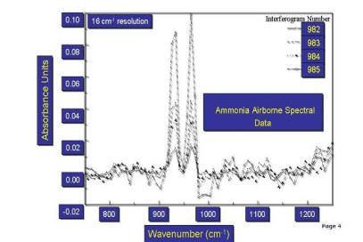
FIGURE 9 - Ammonia Spectra

Passive Airborne Qualitative Detection of a Chemical Compound
FILENAME: H30H092103A
Detection of Ammonia above zero threshold value
> 10 ppm-m
No detection of ammonia below zero threshold
FIGURE 10 - Ammonia Detected with Pattern Recognition

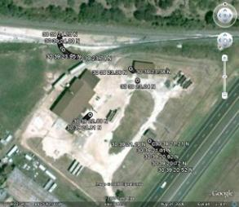
FIGURE 11 - Locations of Ammonia Detection

Quantitative compound specific information is also generated using the MR-254AB spectrometer. This application uses a multi-dimensional model generated using radiometric, thermal, and concentration calibrated laboratory data for each compound in the airborne library. As with compound detection methods, multiple publications have documented the feasibility of using this approach to remotely quantify chemical vapors. The first open literature scientific peer reviewed paper was completed using the ASPECT method.

Figure 12 shows the estimated concentration measured by ground sensors and compared with the remotely collected FT-IR data. The data shows a standard error of prediction of 18 ppm-m for a range of concentration between 20 to 400 ppm-m. This range of concentrations is consistent with both hazardous vapor releases and terrorist concerns.

First Quantity

Figure 12 - Quantitative Methanol Results

- Radiological Detection Capabilities

Airborne radiological measurements are conducted using three fully integrated multi-crystal sodium iodide (NaI) RSX4 gamma ray spectrometers (Figure 13). Each RSX4 spectrometer contains four 4”x2”x16” doped NaI crystals each having an independent photomultiplier/ spectrometer assembly. One RSX unit is configured with an additional upward NaI crystal utilized to provide real-time cosmic ray correction. Count and energy data from each crystal and pack is combined using a self-calibrating signal processor to generate a virtual detector output. All spectrometer “packs” are further combined using a signal console controlled by the on-board computer in the aircraft. Due to the advanced signal processing techniques unique to the RSX4 units, very high total count rates (approximately 1 million counts per second) can be discriminated and processed. In addition to NaI detector system, ASPECT also flies three 3” x 3” LaBr crystals and a four-tube helium-3 neutron detector. These additional systems provide improved spectral information for radioisotope identification and determine if neutron emitters are present.

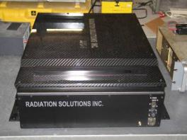
FIGURE 13 - RSX4 Gamma Ray Spectrometer

Radiological spectral data, GPS position, and radar altitude are collected at a one-second interval at all times during a survey. In order to provide optimal collection geometry, flight line data is loaded into the aircraft flight computer prior to conducting the survey. Typical airborne surveys are flown at 300 to 500 feet AGL.

Proper spectrometer operation and data quality assurance is maintained using both internal and external calibration algorithms. A self-contained internal calibration algorithm acts as a watchdog and continuously monitors the spectrometer systems for proper system operation and data output. If any errors are encountered with a specific crystal and/or spectrometer pack during the collection process an error message is generated and the data associated with that crystal are removed from further analyses. External calibration procedures are routinely executed and consist of both designed data collection over characterized areas and pad calibrations over known quantities of radiologically doped concrete. Technical specifications for the RsX4 gamma ray spectrometers are contained in Table 5.

TABLE 5 - RX4 Technical Specifications
System: | RSI RSX4 Gamma Ray Spectrometer
Detector: Gamma Ray | 4 Doped NaI Detectors per pack, 3 Packs, 2x4x16 inch crystals,
Detector: Cosmic Ray | One 2x4x16 upward crystal integrated into one of the RSX units.
Total NaI Detector Volume: | 25 liters
Energy Coverage: | 0 – 3000 KeV
Number of Channels: | 1024
Energy Resolution: | Approx. 3 KeV per Channel
Scan Rate: | 1 Hz
Internal Calibration: | Automatic based on Natural K, U, and T
Field of View (FOV): | 45 Degrees
Cross Field Scan Coverage: | 300 meters @ 300 meter collection altitude (AGL)
Altitude Determination: | 2.4 GHz Radar Altimeter, 10 Meter DEM Database
Power: | 28 vdc @ 4 amps full load (3 Packs)
Weight: | 136 Kg (300 lbs.)
Spin-up Time: | Less than 5 minutes
Standard Outputs: | 1024 Gamma Ray Spectra, GPS (2 Hz)
Data Processing | 1 Step Full Processing of Total Count, Sigma, and Exposure Rate, Approximately 1 minute Processing Time After Data Collection.

      - Radiological Data Processing

All radiological data is processed automatically using airborne algorithms. Normally, a specifically designed survey flight path is flow by the aircraft and once complete, a suite of radiological products is generated from the collected data. Since radiological sources are universally present from the earth and from cosmic sources, all radiological data must be corrected to establish a baseline measurement. Cosmic estimates are established by flying the aircraft 3000 feet AGL while collecting gamma spectral data. At altitudes of 3000 feet and greater all radiological inputs are either from the cosmic sources or the aircraft (which is a constant). Quantified cosmic contributions are stripped out from all subsequent data. Depending on the length of the radiological survey, cosmic backgrounds may be collected at the beginning and end of the survey. In a fashion similar to the cosmic correction, the natural radiological background for the survey area is also established. This process normally calls for collecting a limited amount of data (a test line) at the survey altitude (300 – 500 ft. AGL) in an area of similar geology/land use but outside of the region of survey interest. By subtracting the test line data from the survey data, a corrected radiation map for the survey area is generated.

Several data products are generated automatically by the system including total counts, a sigma map, and an exposure map. The total count product is generated by mapping the corrected total count data (approximately 30 – 3000 KeV) from the spectrometers using the integrated GPS data as the geographic datum. Exposure Rate mps are normally contoured at regular intervals in micro-Roentgens (µR). Figure 14 illustrates a typical survey total count plot.

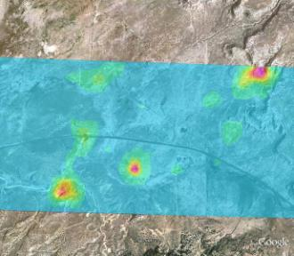
FIGURE 14 - Total Count Plot

A second radiological product includes an array of isotope specific sigma plots or maps. These plots are very useful to the first responder since they help highlight specific data points that may require detailed ground investigation. This procedure consists of a two-step method with the first being a windowing for selected isotope energies followed by a statistical treatment of the data. Isotope specific data is generated by windowing the gamma spectrum at energy levels corresponding to the isotopes of interest. As part of this analysis, higher energy contributions from uranium and thorium are removed using a stripping coefficient. A statistical average and standard deviation is next computed for the entire survey area using the isotope windowed data. Since the standard deviation provides a measure of the variance of the data set, data values showing several standard deviations (sigma) indicate that these values are statistically different from the majority of the population. ASPECT uses a graded scale in which 0 to 4 sigma are considered normal and greater than 4 sigma highlights data very different from the population. Greater than 6 sigma indicates that the data is extremely different and warrants additional investigation. By using different isotope windows, a number of sigma maps can be generated for a given survey (Figure 15).

The final set of products generated by the gamma ray spectrometers consist of an exposure plot or map. This procedure consist of extrapolating the measured total count data collected at the flight altitude down to the total count that would be measured 1 meter above the surface. This method utilizes a weighting algorithm that provides more focus on the high energy counts since these represent the most energetic and penetrating gamma rays. The extrapolation process is accomplished using the calibration coefficients developed as part of the exterior calibration process. The resulting data is plotted in µR/hr and provides the first responder with a health-based estimate of radiological dosage at the ground surface (Figure 16).

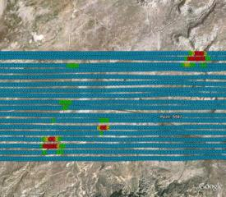
FIGURE 15 - Sigma Plot

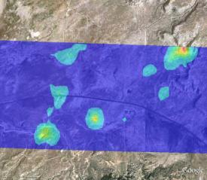
FIGURE 16 - Exposure Plot

    - Visible Imaging Technology

ASPECT utilizes a still digital Nikon DX2 camera to collect and provide visible aerial imagery as part of the core data product package (Figure 17). The DX2 consist of a 12.4 mega pixel CMOS camera supporting a 3:5 aspect ratio frame. The system uses a 28 mm wide-angle lens to provide an image of similar size to the RS800 IRLS generated image. The digital camera is slaved to the primary IR sensors and provides concurrent image collection when the other sensors are triggered for operation. All imagery is geo-rectified using both aircraft attitude correction (pitch, yaw, and roll) and GPS positional information. Imagery can be processed while the aircraft is in flight status or approximately 600 frames per hour can be automatically batch processed once the data is downloaded from the aircraft. Technical specification for the DX2 camera is provided in Table 6.

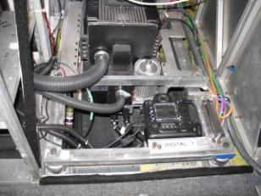
FIGURE 17 - DX2 Aerial Digital Camera

TABLE 6 - DX2 Aerial Digital Camera Technical Specifications
System: | Nikon DX2 Camera Body
Detectors: | 12.4-megapixel digital CMOS sensor
Aspect Ratio: | 3:5
Lens: | 28 mm Digital Compatible
Field of View (FOV): | 824 meters Cross flight and 548 meters Direction of Flight @ 850 meter collection altitude (AGL)
Pixel Resolution (IFOV): | 19.2 cm @ 850 meter collection altitude (AGL)
Frame Timing and Collection Rate: | Operator Selectable, 3 to 8 seconds, Approximately 600 frames per hour
Trigger Control: | Automatic, Manual, and Slave
Power: | 12 vdc @ 1 amp full load
Spin-up Time: | Less than 2 minutes from System Start
Standard Outputs: | JPEG, Tiff
Data Processing: | Full INS/GPS Geospatial Rectification

In order to provide situational information from the perspective of the flight crew, ASPECT also supports an oblique camera system that is operated from the right side of the aircraft. This camera consists of a Canon EOS Rebel digital SLR camera body with a 30 – 120 mm variable zoom lens (Figure 18). Frames are collected at an approximate the 2 o’clock position relative to the aircraft with the target approximately 1000 meters from the aircraft. Table 7 provides technical specification of the oblique camera system.

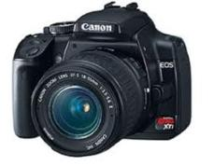
FIGURE 18 - EOS Oblique Camera

TABLE 7 - Canon EOS Aerial Oblique Digital Camera Technical Specifications
System: | Canon EOS Camera Body
Detectors: | 6.3-megapixel digital CMOS sensor
Aspect Ratio: | 3:5
Lens: | 30-120 mm zoom, Digital Compatible
Trigger Control: | Manual
Power: | Internal Battery
Standard Outputs: | JPEG, Tiff
Data Processing: | Spatial Geo-reference

      - Visible Imagery Data Processing

Visible imagery collected with the ASPECT System is ultimately processed into a geo-registered jpeg or tiff format image. Image processing is composed of two primary steps including image enhancement and geo-registration. Both of these processing steps can be processed while the aircraft is in flight status but typically, imagery is processed once the aircraft lands due to the large quantity of data involved with aerial photography. A standard flight mission often generates 600 aerial images.

The ASPECT aerial camera consists of a still frame 3x4 ratio digital camera. A wide field of view lens is utilized to match the ground width coverage of the line scanner system. Due to the speed of the aircraft and the fact that ASPECT may fly in low light conditions, the camera uses a fixed focus and shutter speed configuration. Raw imagery is subsequently processed to balance contrast and saturation of each image. In addition, since a wide-angle lens is used, edge distortion is corrected using a custom-built camera model. Both of these overall algorithms are executed automatically in a batch processing system.

The ASPECT camera is fix-mounted to the primary optical base plate. The camera axis is bore sighted to within 0.5 degrees to the axis centers of the other optical systems. While images are being collected, a concurrent system collects both GPS data and inertial data to provide a high-resolution pitch, roll, and yaw correction dataset. An automatic software package merges these data set and geo-corrects each image using a triangular correction mode. The resulting images statistically show less than 11 meters of center frame positional error and less than 1 degree of rotational error. As with the frame enhancement processing, geo-registration is accomplished in a batch mode at a rate of approximately 800 images per hour. Following registration, images can be directly used by the responder or further corrected with minor positional and rotation corrections (Figure 19).

If requested by the data user, aerial photography (and IR imagery) can be stitched into a wide area mosaic. While this process does take some time, a 4 square kilometer mosaic image (approximately 8 frames) can be assembled in about 2 hours (Figure 20).

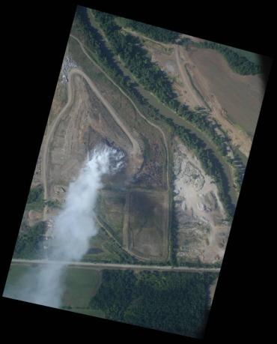
FIGURE 19 - Digital Aerial Visible Imagery

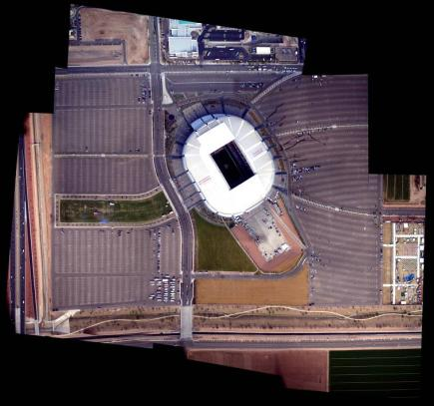
FIGURE 20 - Mosaic Imagery Product

Oblique digital photography is processed to capture the situational environment from the perspective of the flight crew. All frames are collected from the right side of the aircraft at approximately 45 degrees from the nose of the aircraft. During automated processing, GPS data is used to provide the position that the frame was collected and the direction that the frame was collected is determined from the track of the aircraft and the relative direction that the camera was operated from within the aircraft. Figure 21 illustrates an example of an oblique image.

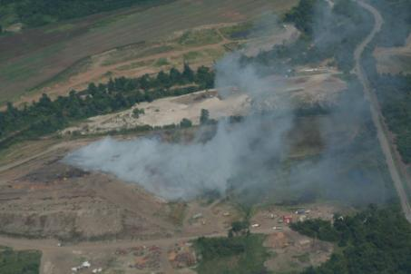
FIGURE 21 - Oblique Aerial Image

    - Data Communication Technology

The ability to rapidly transfer data from the ASPECT aircraft to the ultimate end user is mandatory if the system is to support emergency response functions. ASPECT uses a state of the art satellite-based communication system that provides broadband data through put while the aircraft is in flight status (Figure 22). The system consists of an electronically steered phase array satellite antenna coupled to a RF power amplifier/receiver supporting a wired onboard computer TCP/IP modem/network. All components of the system have been installed and certified as part of a formal FAA STC procedure. The system utilizes a geosynchronous satellite connection and permits full rate communication throughout the contiguous U.S. Table 8 contains the technical specifications for the satellite communications system.

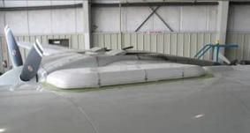
FIGURE 22 - Satellite Communication System Phased Array Antenna

TABLE 8 - Satellite Communication Technical Specifications
System: | Chelton Broadband Satellite System
Antenna: | HGA-7000 Electronically Steered Phased Array Antenna.
Modem: | Integrated Airborne Modem/Router, 100 MB/s data rate
Power Amplifier: | HPA-7400 Bi-directional Power Amplifier/Pre-Amplifier Short Coupled to the Phased Array Antenna.
Data Rate: | Up to 332 kbs (Approximately 60 Kbs) Full Duplex
Constellation Type: | Fixed Geo-Synchronous
Coverage: | Continuous Coverage Over the Lower 48 States.
Certification: | FAA STC
Power: | 28 vdc @ 10 amp full load
Spin-up Time: | Less than 2 minutes from System Start
Standards: | TCP/IP

- Technical Coordination and Support

The ASPECT Data Team will be collocated with the 64th CST during early morning radiological surveys and at the State of New Mexico Department of Homeland Security. During chemical and/or photographic flights, the team will be located at the Department of Homeland Security. All data collected will be analyzed and plotted to support Region 6 for the event surveys. It is anticipated that the team will be active on 4 October 2014. This data analysis support will provide information in four formats to include: (1) digital data stored on an FTP site, (2) communication through conference lines, (3) hard copy displays, and (4) data presentation and display through ESRI Flex viewer and Google Earth. Procedures to access this information are provided in Appendix C.

The data team will also provide hardware support to the aircraft sensors, including backup radiological and camera systems. In the event that these systems show faults, the team will exchange the reserve sensors.
Appendix C
ASPECT Data Routing, Storage and Viewing

ASPECT data consists of several distinct file types. These data types include: (1) visible camera images, (2) visible images in a data format capable for import to GIS packages, (3) wide-area high spatial resolution infrared GIS maps, (4) processed infrared spectra showing vapor species identified, (5) maps showing the location of flight paths, (6) processed chemical data, (7) processed gamma ray data, (8) data logs containing information about each collected data file, and (9) data analysis reports (in Microsoft Word) and Excel format. All released data will be routed through the EPA Region 6 OSC.

ASPECT uses onboard data processing to accelerate the delivery of data. Both chemical and radiological data are processed while in flight status and a data package is extracted from the aircraft using the satellite data system. All data is QA reviewed by the ASPECT team prior to delivery to the Region. Once data has been certified, it is immediately transferred to the Region for use.

Data Storage

The raw data collected as part of the Albuquerque Balloon Fiesta will be archived at the URL site: ftp.epaaspect2.net (host); xxxxxxxx (user); password available upon request. The file structure in the archive will be the following for both the raw and processed data. The raw data will be under “raw” while the processed data will be under “processed”. The standardized files structure used is contained in Table 1.

Table 1 - Data File Structure
Main subdirectory labeled with Date and Flight number
File | Contents
DIGITALS | Raw NADAR aerial digital photography data and event (shutter) times.
FTIR | Raw FTIR spectral data
GAMMA | Raw gamma spectral data
GPS | Raw gps positional data and inertial navigation data
IRLS | Raw line scanner data
OBLIQUES | Raw oblique aerial digital photography data
PROCESSED DATA | Processed data consisting of:
PROCESSED DATA | Processed Digitals | Georectified NADAR color photography
PROCESSED DATA | Processed FTIR | Georectified chemical detections  Text data package
PROCESSED DATA | Processed GAMMA | Georectified Sigma Plot  Georectified Exposure Contour Plot  Text data package
PROCESSED DATA | Processed IRLS | Georectified 3-band IR imagery
PROCESSED DATA | MOSAIC | Georectified color photography mosaic
PROCESSED DATA | Processed Obliques | Georeferenced color oblique photography
Reports | Completed mission reports and mission updates
Run sheets | Scan copies of written in-flight collection logs  Mission orders

Data Distribution
Distribution of data will be under the control of Region 6. To aid in this process a secure website has been developed and can be found at http://www.epaosc.org/(TBD)
An event specific website will be generated that contains an array of data products with a listing contained in table 2. The website can be password protected if required by the OSC. In addition, a separate Google Earth n-link can be provided to users on request.
Table 2. Website Data Products
Google Earth Products (Using the n-link)
Flex Viewer Data Products
Google Earth Map Products
Google Earth API Data Products
Misc API Data Products
Mobile Device Data Products

Google Earth Instructions
For users wishing to use the Google Earth n-link products the following instructions detail how to load the free software and use the system.

Use of this tool requires that an up-to-date free version of Google Earth and a suitable web browser (Internet Explorer, Chrome or Firefox) be installed on the user’s computer. Access to all data is facilitated through a small kml file. The following instructions detail how to use the tool:

1. Using your email server download the KML file to your desktop if you received it through email. If provided on a memory stick, simply copy the KML file to your desktop.
2. To open the kml, double click the file located on your desktop. This will automatically bring up your Google Earth Program, and the ASPECT airplane icon will appear and zoom to the geographic area of the mission.
3. The ASPECT airplane icon provides total access to all of the data available for the mission. Double Click the airplane and a balloon will expand listing all of the relevant information for this particular ASPECT mission. The relevant information available may vary from mission to mission. All of the sections depicted in blue are links to data on the ASPECT mission servers. The following is a brief description of each section:

Brief Mission Description
This section contains details of the overall mission and specific details of the current mission which will open up in a separate browser window. When completed with the section close the browser window to return to Google Earth.

Sensor suite capabilities
This browser window contains a description of the sensors used on ASPECT aircraft. When finished with this section close the browser window.

Color aerial photography
Clicking the color aerial photography section permits georectified NADAR images to be displayed and/or downloaded using the Google Earth. Once selected, available images from the last mission will be displayed as transparent outlines on the main screen.
Note: By default, only outlines from the last mission are displayed. Additional images collected on prior missions can be selected under the places menu on the left side of the Google Earth tool.
To load the actual imagery into Google Earth, click on a camera icon in one of the polygons. A photo balloon will open and a thumb nail of the non-georectified photograph will be displayed. Two options are given at the bottom of the image:
Download Image Overlay into Google Earth
Download High Resolution Image into Web Browser
By clicking on the “Download Image Overlay into Google Earth” the image will be imported into the Google Earth imagery database and the georegistered image will be shown on the screen. Repeat this process for as many images as you are interested in. Note: each time you execute this procedure the referenced aerial photograph frame will appear in blue in you temporary places pane on the left hand side of the Google Earth window. Should you want to view a full resolution image of this frame, click on the option “Download High Resolution Image into Web Browser”. The full resolution image will be displayed in a separate browser window.

Mosaic Aerial Photography (By Date)
Selection of a color mosaic will load a georectified color mosaic into Google Earth. Selected of the appropriate image is referenced to the date of collection. Due to the large size of these files, several minutes may be required to fully download the file.

Oblique Photography
Viewing of oblique color aerial photography is accomplished by selecting the oblique photography item. Once selected, available oblique images for the last flight will be displayed as a collection of arrows. These arrows represent the location that the aircraft was positioned and the direction the camera was pointed when the frame was collected out of the right side of the aircraft. As the curser is moved over the respective arrows, the frame number will be highlighted. If an arrow is double clicked a thumb nail of the image will be displayed. The user has the option of downloading the image in a browser.

Infrared Color Imagery
Multi-channel color infrared imagery is selected using this option. Once selected, transparent outlines of available images from the last flight will be displayed. Operation and manipulation of IR imagery is identical to procedures used to view color aerial photography.

FTS Confirmed Detection
This section contains the locations of confirmed remote sensed chemical detections for the last mission. Detections will be displayed as an icon. Each detected compound will be displayed as a unique icon. As with other data, data from prior missions can be selected under the places menu.

Chemical Report Retrieval
Chemical data associated with FTS confirmed detections is contained in this section. Each report shows a listing of compounds which are automatically scanned by ASPECT. The number of detections, maximum concentration, and the coordinates of the collection line are given in the report.

Aircraft Flight Tracks (By Date)
Flight track information for the last mission is available using this selection. Once selected, a color flight path will be displayed. Multiple tracks can be displayed by selecting additional paths from other missions.

New Data Additions
As new data is added to the mission website the provided Google Earth link will permit full access to the new data. You must periodically close the Google Earth program and re-open it again using the Google Earth icon on your desktop. When you exit the program, Google Earth will prompt whether to save your “temporary places”. Select discard. Depending on the amount of data being collected and uploaded to the mission server, reloading the Google Earth program once each hour will permit access to the new data.

Trouble Shooting
If you are having problems with multiple ASPECT airplane icons appearing on the screen do the following:
- Locate the Places Box on the upper left hand side of Google Earth.
- Locate the line labeled as My Places.
- Right click on My Places and select Delete Contents
- Close Google Earth and reopen using the Google Earth Icon on your desktop

Flex Viewer Instructions
For users wishing to use the ESRI based Flex viewer the following instructions detail how to use this data viewer.

          - From the website, select the Flex Viewer Products and click once. A new website window will open showing a map of the general area.
          - In the upper right corner of the image place the cursor over the icon labeled MORE. A number of products will open.
          - Using the side slider of the window, navigate to the data products to be displaced and click on the small blue box left of the product. A check box will be highlighted.
          - Depending on the speed of the internet connection, icons will appear on the display showing for chemical and radiological products and an image will appear for visible and IR imagery products. Note: it may take several minutes for complex data such as images to appear if the internet connection is slow.
          - To rapidly zoom to a selected data product that has been selected to be displayed, while in the MORE icon, click on the arrow to the right of the selection then select the ZOOM TO option and click once, the display will highlight the selected product in the middle of the display.
          - To remove items from the display window, return to the MORE window and click once on the checked box to remove the item.
          - Data products shown in the MORE window can be downloaded for other uses by selecting the down arrow to the right of the product listing. Select the DOWNLOAD option and a download options window will open. Select either the kml or png file type and then select open or save, depending on your needs.
          - While in the Flex Viewer main data window, navigation can be accomplished by left clicking and hold and simultaneously moving the mouse to drag the image to the required location and/or using the navigation controls located in the left side of the image.

Appendix D
Communications

Phone Conference Call Bridge
The ASPECT program has a dedicated 24/7 phone bridge which be used to communicate with the reach back data analysis team.

Phone bridge # (toll Free): 1-866-299-3188
Code: 9135515018#

Direct Tracking of Aircraft from EOC
Due to flight restriction issues, FAA will not provide public tracking of the aircraft during the Temporary Flight Restriction (TFR) period since the aircraft will be flying under a secure squawk code. The aircraft will be providing periodic SPOT tracking and Google Earth updates so the location of the aircraft will be known. This information will be made available as part of periodic status updates on the mission.

Google Earth Link for Data Display
The data analysis cell located at the State of New Department of Homeland Security will be processing data collected from the aircraft and processing it into a format that can be accessed through a Google Earth file. This file will contain processed data providing situational awareness information. A Google script will be provided to the State event manager for distribution.

Direct Aircraft Communications
Direct radio communication with the aircraft will be conducted using 123.45 MHz (AM) during the event.

Appendix E
Contact Information

New Mexico State Police

Mark C. Rowley
Director/RSO
Hazardous Materials and Radiation Protection
New Mexico State Police
Email: mark.rowley@state.nm.us
Phone: 505-476-9604
Cellular: 505-660-5441
New Mexico Department of Homeland Security and Emergency Management

Richard A. Clark, Jr.
Homeland Security Planner
New Mexico Department of Homeland Security and Emergency Management
Email: richard.clark@state.nm.us
Phone: 505-476-0872
Cellular: 505-231-5245

New Mexico 64th Civil Support Team

Maj James Willis
Operations Officer
Email: james.c.willis36.mil@mail.mil
Phone: 505-474-2204
City of Albuquerque
Fernando Aragon
Lieutenant/Watch Commander
Albuquerque Police Department
Northwest Area Command
Email: faragon@cabq.gov
Cellular: 505-553-2217

Mick Rael
Patrolman/AIBF PRND Commander
Albuquerque Police Department
Email: mrael@cabq.gov
Cellular: 505-659-5495

Event Manager
Don Edwards, Event Director
Albuquerque International Balloon Fiesta, Inc
Email: dedwards@balloonfiesta.com
Phone: 505-821-1000
Cellular 505-503-3812

U.S. EPA Region 6 Contacts

Jon Rinehart, On-Scene Coordinator
US EPA Region 6
Email: Rinehart.jon@epa.gov
Phone: 214-789-1713

ASPECT Team
Mark Thomas, ASPECT Main POC
Environmental Protection Agency
Email: thomas.markj@epa.gov
Phone: 513-675-4753

Tim Curry, ASPECT
Environmental Protection Agency
Email: curry.timothy@epa.gov
Phone: 816-718-4281

John Cardarelli, ASPECT GEM
Environmental Protection Agency
Email: cardarelli.john@epa.gov
Phone: 513-675-4745

Paul Kudarauskas, ASPECT
Environmental Protection Agency
Email: kudarauskas.paul@epa.gov
Phone: 202-344-5382

Robert Kroutil, ASPECT Support
EPA Contractor
Email: Robert.kroutil@kalmancoinc.com
505-795-4762

Jeff Stapleton, ASPECT Support
EPA Contractor
Email:jeff.stapleton@kalmancoinc.com
757-634-2900

ASPECT Flight Crew
Sam Fritcher
Airborne ASPECT
410-258-6281

Beorn Leger, Chief Pilot
Airborne ASPECT, Inc.
Phone: 972-921-1893

Travis Smith, Pilot
Airborne ASPECT, Inc.
Phone: 903-461-2959

Gerry Boyles
Airborne ASPECT, Inc.
Phone: 214-448-9086

Dallas Slay
Airborne ASPECT, Inc.
Phone: 972-977-4582

Perry Wagner
Airborne ASPECT, Inc.
Phone: 469-288-9011

